2017

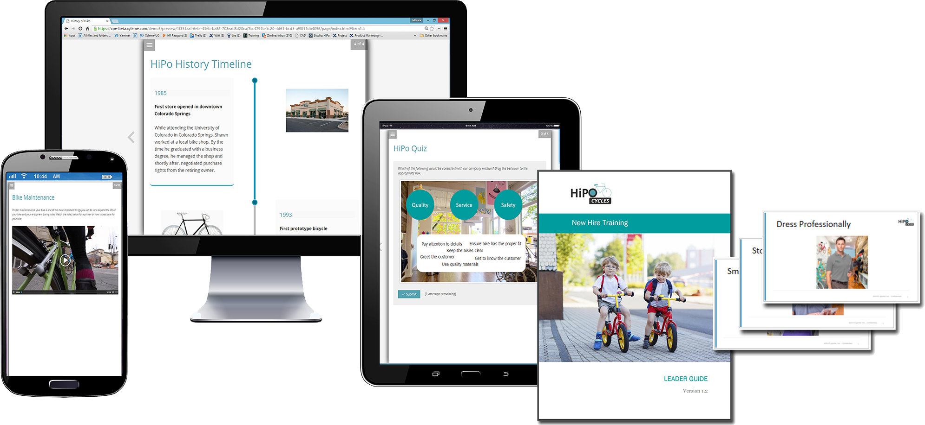

BUSINESS CASE for Learning Content management

<ORGANIZATION NAME>

author name

Contents

Executive summary 2

1 Business Opportunity 5

Learners 5

Subject Matter Experts 7

Content Developers 6

2 Possible Solutions 8

Options 8

Option 1: Status Quo 8

Option 2: Homegrown solution leveraging ECM tool 8

Option 3: Content strategy and Xyleme 8

Pros/Cons analysis 9

Cost/Benefit analysis 10

3 Recommendation 11

Recommended Solution 11

Building support 11

Go / No Go Decision 11

Appendix 12

Communications Package 12

# Executive summary

*[The*[***executive summary***](http://www.skillsyouneed.com/write/executive-summary.html)*summarizes the business case, including your recommendation. It is often best written last, when you’re clear about your recommended course of action, and why. Remember that some decision-makers may only read the executive summary, so you need to make sure that you have included everything relevant.]*

Our learning content is a strategic advantage in our business environment that is constantly changing. It is a significant investment and we have not yet put in place the process and infrastructure needed to fully leverage and monitor this vital business asset.

Our company needs a content management solution to:

*[key business drivers – keep it to 3]*

* Capture expert knowledge in a single source for ease of maintenance and delivery
* Make content more accessible and effective for employees at their time of need
* Streamline content development efforts to reduce costs

*[summary of issues]*

Today, learning content assets resides on internal and vendor servers, inside and outside of our organization’s firewall. Our learning managers struggle to effectively prevent duplicate efforts, repurpose existing content, manage versions, prioritize enhancements, measure usage and protect our content investment for the future. Development cycles and maintenance of learning materials are too slow and resource-intensive, causing courses to lag behind, out of sync with current practices and pressing business needs. As a result, L&D isn’t able to govern all of the content used for training, leaving employees, partners and customers to discern what content is current. This creates unnecessary business risk.

*[vision statement]*

Our vision is to be a high-impact learning organization, where we can consistently deliver learning outcomes which will improve organizational performance. To do this we need to get our content working for us. Content management strategy and technology can save us time, money and effort, while increasing the velocity of our solutions. We will be able to deliver projects 60-70% sooner and reduce translation and maintenance costs by 50%. Employees will be able to find and access curated content when they need it, significantly improving productivity and engagement. Finally, the intellectual capital of our experts will be captured in a centralized source and distributed organization wide, ensuring a consistent message to employees, partners, and customers.

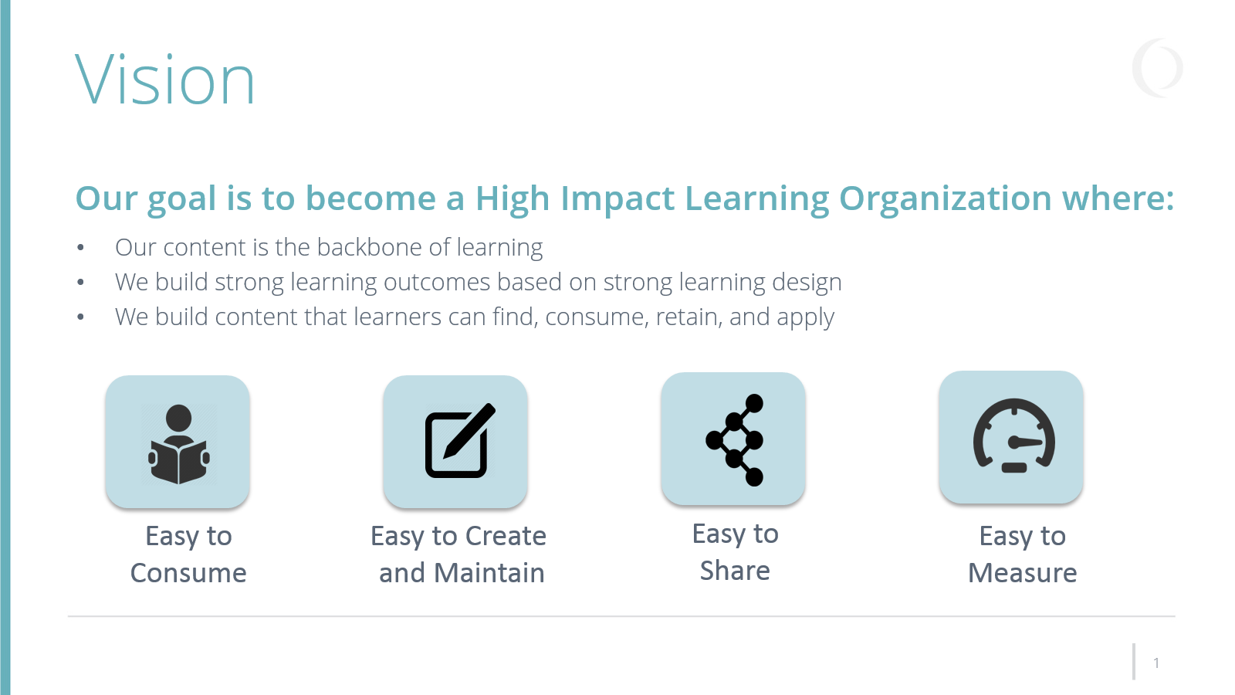

*[solution description and benefits]*

How can we achieve this vision? We have considered a home-grown solution using our current enterprise content management system, however it does not support learning standards such as SCORM, xAPI, and XLIFF that are critical for interoperability with our learning and translation systems. Nor does it support the concept of learning objects that are needed for highly consumable, searchable, scalable and measurable content.

We recommend implementing a unique market solution; Xyleme – that will allow us to manage the learning content lifecycle using an integrated and collaborative approach. Content produced in Xyleme integrates easily with our other learning and ops systems without IT projects or customizations. Content that we produce outside of Xyleme can be stored centrally as part of the cloud infrastructure too. Content that we develop for learning can also be used in the help system, on the web portals and LMS all from the same exact source.



**LMS**



**Mobile**

**App**

**Add to**

**Issue ticket**

**Embed in**

**product help**

**Customer**

**Portal**

**Our**

**Portal**

**Repository and**

**Learning Record Store**



**Support**

**Training**

*[call to action/next steps]*

Having checked out other organizations that have implemented a content management solution with Xyleme, we can expect payback in year one with significant return-on-investment in the years to follow. Initially, by implementing authoring and publishing templates that are tailored to our brands and needs, we will produce more standardized, beautiful and interactive content more quickly for print, web and mobile. By distributing our content from Xyleme, we will streamline content integration with all of our systems and capture analytics about how our content is performing. Down the road, it is the maintenance and reuse of content that will provide the biggest ROI year over year.

Effective change management is always a consideration when implementing a business transformation project like this one. In order to gain support and adoption, the recommendation is to start with a small core team on a highly impactful project to show the power of learning content management. Upon review and approval by management, we will expand both the scope of the team and the content project.

We are looking for your support and approval to move forward on transforming our strategic content into a powerful business asset that can have lasting impact on our business.

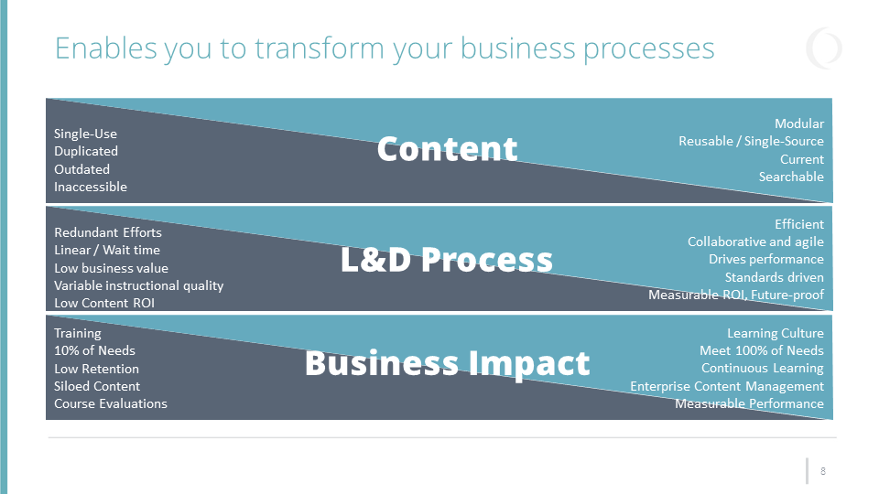

# 1 Business Opportunity

*[This should be a brief paragraph stating the problem. It should relate back to the organization’s strategy or vision to demonstrate how solving the problem is important to the organization.]*  
Efficient, effective content management is a strategic initiative that will preserve budgets and intellectual resources, while enabling employees to access information at the time of need to propel workforce productivity. Today, our company is limited in our potential to use content strategically. The following issues restrict our potential:

*[Select key issues that apply to your current situation]*

## Learners

| **Problem** | **Problem Description** | **Opportunity** |
| --- | --- | --- |
| No time to sift through pages of search results | Users often search for content at the time of need, under deadline. They cite that they do not have time to sift through inefficient search results, and often turn to internet searches to find content that they can repurpose for company needs | By keeping content in a central learning object repository, it can be easily found at the course or object level, and served up to any systems or applications. We can use the mobile portal from the LCMS vendor without additional mobile app development. |
| Content overload | The content inventory is an overwhelming collection of files. It is difficult to identify what’s current, what’s relevant to my job role, what information is valued by others in the company | Content analytics inform developers for prioritization of content improvement needs and shows usage at the granular level by user and group |
| Limited window to learn | Difficult to find time to sift through long documents, sit through a recorded webinar, or click through an entire eLearning course | In the system, we can create bite-size content which can be distributed in chunks or assembled for courses, or job-specific learning paths |
| Difficult to know where to search for content | With so many formal and informal content repositories, users do not know where to start the search for information | Serving the content from a single system by way of public or private link will not force learners to log in to the LMS to find content. I can be put in their path from existing business applications (i.e. help system), or in a website/portal, or an LMS. |
| Accessing content at the time of need, from the device of their choice | Users need content at the time of urgency, and often encounter obstacles to accessing content due to file types | Users can quickly find what they want and narrow the results by their preferred format, i.e. video, print or online course. |

## Content Developers

| **Problem** | **Problem Description** | **Opportunity** |
| --- | --- | --- |
| Accessing content for reuse | Our content development team is distributed and does not share a central repository or workspace for content. Source files are located on internal and vendor servers as well as on laptops, desktops, external hard drives, SharePoint sites and email files. | Collaborative authoring between Instructional Designers, SMEs and business stakeholders breaks down development silos and makes the shift to agile development processes smoother by finishing smaller work products faster |
| Organizing content for reuse | Our content development team does not have a unified system for organizing content. | A shared workspace allows teams to create a clean, systematic inventory, and promotes content reuse |
| Version control | With potential for multiple versions of the same content, content developers lack confidence that the correct version of content is being inserted and perpetuated in new formats | Version control enables teams to quickly and accurately identify the correct resources and eliminates rework and duplicate effort. |
| Translating content | Our content development team does not have time to translate content for each of our regions | Content format (XML) significantly reduces translation complexity saving 30-50% on translation costs |
| Promoting content awareness | Our content development team creates a lot of valuable content but does not have the time to promote it through multiple channels | A repository for our learning products would streamline communications about high value content to all stakeholders |
| High demand for repackaging popular content for web, print and mobile delivery | Our content development team is routinely asked to create content on topics that we have addressed and may be in our inventory, but our team is small and we don’t have time to deconstruct and reassemble content in a different format | Reusing existing content blocks that are device and context-agnostic, Instructional Designers avoid recreating content for every new project, modality, device and audience. Separation of content from presentation eliminates formatting efforts and cuts as much as 30-50% development time. |
| Refreshing high frequency content | Our content development team does not have time to refresh information on recurring topics in every content source | We can change the content once and it will update in all the places it is used. This will save us hours of maintenance time and will encourage more frequent update cycles. (i.e. monthly instead of annually) |
| Limited budget for content development | Our content development team has more demands on our time than our limited staff can handle, and our budget for contract support is limited | Our content development team spends 30% of our efforts formatting content. Publishing templates would eliminate this time and give each designer the ability to create beautiful outputs for print and web in minutes. |

## Subject Matter Experts

| **Problem** | **Problem Description** | **Opportunity** |
| --- | --- | --- |
| Limited time to contribute | Subject matter experts who have the knowledge to participate in creating content are also sought after for their problem solving skills in other areas of the business | By working in an authoring template, SME content will be easy to import, process and maintain. |
| Cost to company of overlapping efforts | Often, peer subject matter experts are asked to contribute to various content creation efforts without recognizing that content already exists | A single-source content management system would allow us to manage content more effectively, selectively request subject matter expertise, and publish content knowledge across the organization |
| Lack of availability at time of content development deadline | Subject matter experts are often involved in a content development cycle, deliverable by deliverable | SMEs can participate in online review sessions asynchronously. |

*[Root Cause Analysis – before moving to the solution step, you may need to dig a bit deeper to understand WHY these issues exist. What is the root cause? Is it your skillsets, toolsets or even mindset holding you back?]*

# 2 Possible Solutions

*[Identify possible options for addressing the problem, including sticking with your current solution or “status quo”.]*

## Options

### Option 1: Status Quo

We can stay the course and develop targeted solutions using rapid authoring tools. However, as the volume of our content expands, we anticipate that many of the problems we just discussed in the prior section will get worse. We may also see a decline in usage as learners seek alternative content solutions online, outside of our sphere of control.

### Option 2: Homegrown solution leveraging ECM tool

Another option may be to develop a business process (governance and workflow) that will let us collaborate more and reduce the redundancy of our content using our existing ECM tool. This will not give us a multi-channel publishing and distribution process from the same source content. Our ECM tool is a document-based solution; it does not support the notion of learning objects. This approach will address some of the issues for content developers but not for the SMEs and learners.

### Option 3: Content strategy and Xyleme

Putting a content strategy in place supported by a content engagement platform like Xyleme, is a business process improvement that will have the greatest impact on our organization. In comparing the various content solutions on the market today, Xyleme is the most advanced and has a proven track record of providing onboarding, change management and content strategy consulting for their clients.

With Xyleme, we will create structured content that is scalable, measurable and reusable. We will be able to work together and increase the velocity at which we deliver learning solutions to the business. Below are some of the tangible benefits we will realize.

**Streamline content development efforts**

* Xyleme customers report as much as 40% improvement in content development productivity. Improved efficiency allows for velocity, shorter development cycles, lower course: developer ratios – and thus, lower headcount, and we are able to do more, with less.

**Reduce content development costs**

* Xyleme customers hold that, on average, up to 30% of total translation costs are associated with inconsistencies that exist in the same content repeated across various documents. Also, to be translated, course material must be “unpacked” (converted to ASCII text/native XML) and then again “repacked” (converted and formatted back to the original document – PDF, HTML, Word…). Dell was able to reduce a 3-month, developer-intensive activity down to a 5-day automated process with Xyleme. Most will save 30-50% on their translation costs.

**Capture expert knowledge in a single source for organization-wide distribution**

* With Xyleme, we can capture expert knowledge once using either the online authoring templates or by importing Word documents, and then manage and deliver that content in multiple ways.

**Higher Content Engagement from any device**

* With Xyleme, we will know what content is hitting the mark and what content is not. Users will have access to content anywhere on any device, in multiple formats.

## Pros/Cons analysis

*[Do a pros/cons analysis on your two or three best ideas. Make sure to include any roadblocks that need to be addressed in the “cons” part of the analysis.]*

|  |  |  |  |  |
| --- | --- | --- | --- | --- |
|  | **Option 1: Status Quo** | | **Option 2: Content Strategy / Xyleme** | |
|  | **Pros** | **Cons** | **Pros** | **Cons** |
| **Collaborative Authoring** | Authors love their tools | * Work in Silos * Redundant Content * Can’t keep up with demand * Hours spent formatting * Multiple versions * Need web development skills to create mobile outputs | * Collaborative Authoring * Content Reuse * Content Migration * Multi-channel publishing * Mobile-ready themes | Change Management |
| **Content Distribution** |  | * Content out of date * Manual deployment process | * Cloud delivery to any LMS * Web Share Links – public and private * Low-level Analytics |  |
| **User Engagement** |  | * Users can’t find content easily * Content is not mobile ready * Hard to support informal learning, performance support | * Granular search * Mobile portal * Bite-sized, informal learning * Highly engaging content |  |

## Cost/Benefit analysis

*[Cost/Benefit analysis will help you estimate the ROI of a potential solution. First figure out and quantify the benefits in dollars and then quantify the costs. The ROI calculation is the benefits/costs expressed as a percent. It is helpful to look at ROI over time. Contact Xyleme to schedule an appointment to do a cost/benefit analysis.]*

*The cost of the solution is offset by the productivity improvements as well as tangible cost savings in other areas.*

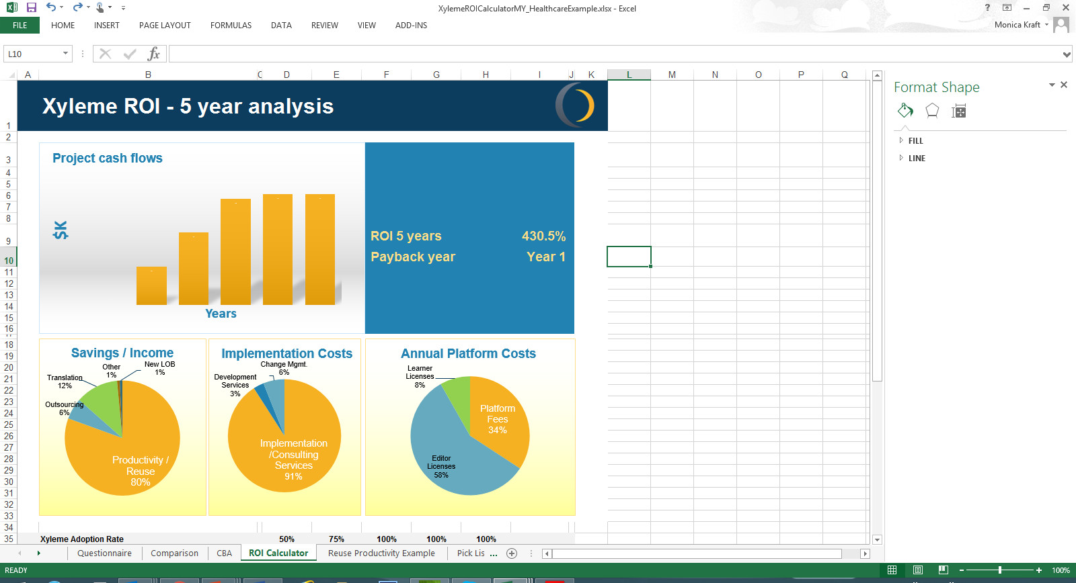

# 3 Recommendation

*[It’s time to make a recommendation and sell your idea. Complete the sections below. Take care to understand how your organization makes decisions of this nature and follow best practices.]*

## Recommended Solution

Based on the analysis done by the team, the recommendation is to move forward on a content strategy and management solution that will help us increase learning in our organization. This will include the creation of a strategy core-team and the purchase and implementation of Xyleme.

## Building support

We understand that an effective content strategy is a cross-functional team effort. To build support for this recommendation, we will prepare and rollout a communications package that clearly states the vision and benefits of implementing a content management strategy to the learning and development teams. We will share our research, demonstrate the system to key stakeholders, hold presentation and round-table sessions, and gather feedback.

## Go / No Go Decision

All feedback will collected and categorized by our decision criteria over the next few weeks. Any budget and procurement considerations will be addressed. At the end of the decisioning phase, we will review the results and determine if moving forward with this recommendation is feasible and in the best interest of our organization.

# Appendix

*[When building a coalition of supporters, you will want to keep the lines of communications open and a sense of transparency about the process and the impacts to individuals, groups and the organization at large. Create a communications package, make it accessible, and go on the road with it, sharing the presentation with other groups that have a stake in your success. Contact Xyleme for help preparing your communications package.]*

## Communications Package

1. Business Case Document
2. Presentation
   1. Vision
   2. Current State
      1. Issues and Impacts
   3. Future State
      1. Solutions and Impacts
      2. Benefits by stakeholder
      3. Cost and ROI
      4. Relevant Case Studies
   4. Implementation
      1. Process
      2. Project
      3. Success Criteria
3. Videos
   1. Xyleme Overview
   2. Content Samplers